MARKETPLACE HACKATHON 2025

DAY 6

DEPLOYMENT PREPARATION & STAGING ENVIRONMENT SETUP

1. DEPLOY: “VERCEL”
2. ENVIRONMENT VARIABLE CONFIGURATION:

.env.local

NEXT_PUBLIC_SANITY_PROJECT_ID=""

NEXT_PUBLIC_SANITY_DATASET="production"

SANITY_API_TOKEN="s"

NEXT_PUBLIC_CLERK_PUBLISHABLE_KEY=pk_test_

CLERK_SECRET_KEY=sk_test_

Wishlist:

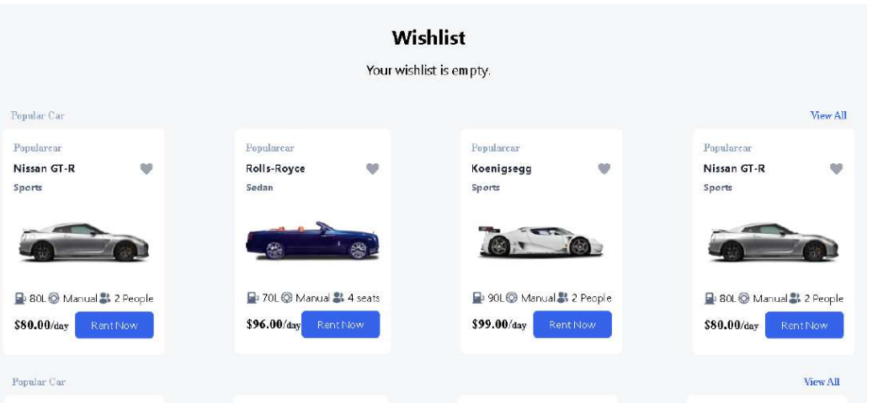

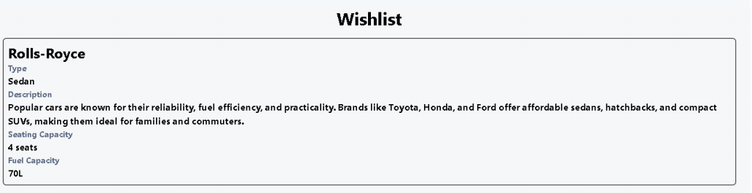

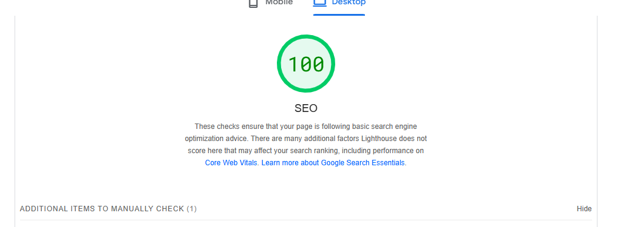

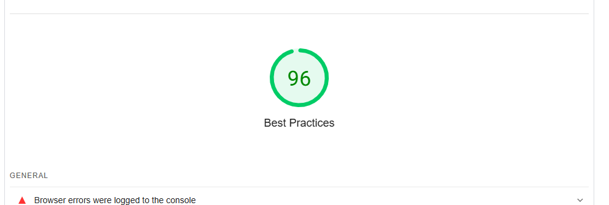

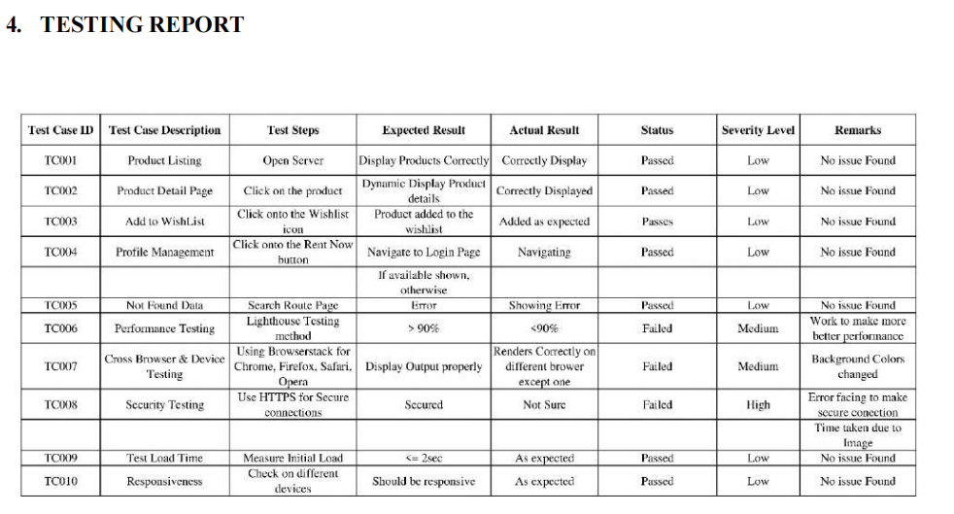

Day 6 complete